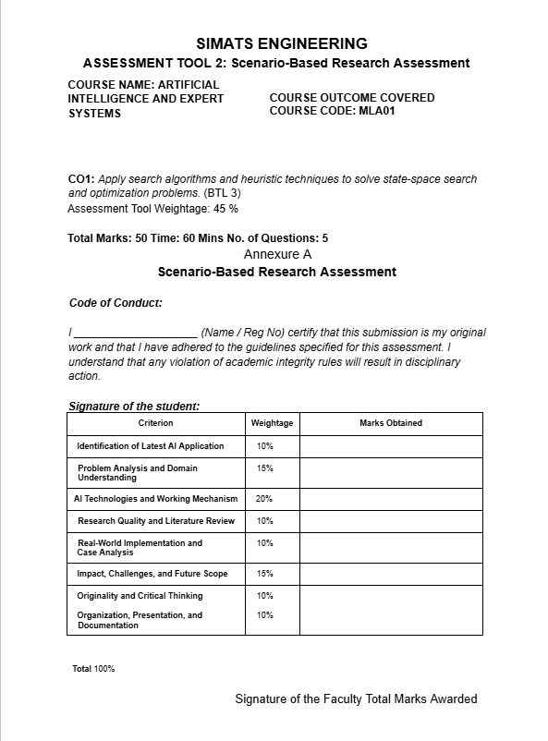
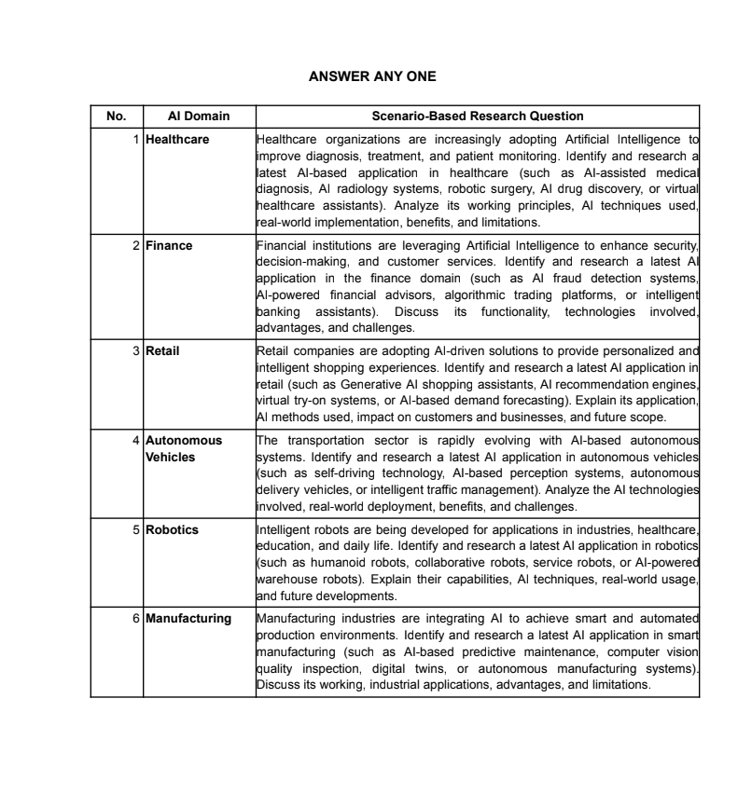

MLA0103-ARTIFICIAL INTELLIGENCE WITH
EXPERT SYSTEMS
ASSIGNMENT TOOL
Name: C.Manogna sri hasitha(192525215)
Department: B.Tech AIML
Faculty name: Dr. M. Prakash

1. Title of AI Application AI-Powered Autonomous Self-Driving Car (Tesla Full Self-Driving) 1. Domain Selection
o Autonomous Vehicles

2. Introduction and Background
o Introduction to Tesla Full Self-Driving, autonomous driving, AI in transportation, and why Tesla uses AI.

3. Problem Identification
o Problems of traditional driving such as human error, accidents, traffic congestion, driver fatigue, and parking difficulties.

4. Need for AI Solution
o Explain why AI is required for self-driving cars, including object detection, lane detection, traffic sign recognition, collision avoidance, and real-time decision making.
5. AI Technologies Used o Machine Learning o Deep Learning o Computer Vision o Neural Networks o Sensor Fusion o Path Planning o GPS Localization
o Reinforcement Learning

6. Architecture Diagram
o A complete Tesla FSD architecture with:
▪ User
▪ Cameras & Sensors
▪ Data Processing Layer
▪ AI Intelligence Layer
▪ Decision-Making Layer
▪ Vehicle Control Layer
▪ Autonomous Driving Output

7. Architecture Components
- Input Layer o Data Processing Layer o AI Intelligence Layer o Decision-Making Layer o Vehicle Control Layer
- Output Layer

8. Working Mechanism
- Step 1: Capture road data using cameras and sensors
- Step 2: Process images and detect lanes, pedestrians, vehicles, and traffic signs o Step 3: AI predicts surrounding vehicle behavior o Step 4: Plan the safest route
- Step 5: Control steering, acceleration, and braking

9. Data Sources and Processing
- Camera images
- GPS data
- Vehicle speed
- IMU sensors
- Wheel encoders
- Traffic sign data
- AI model processing

11. Real-World Implementation (Use Case)
- Organization: Tesla Inc.
- Product: Tesla Full Self-Driving (FSD)
- Daily commuting scenario with autonomous lane changes, obstacle avoidance, traffic light detection, and automatic parking.
12. Impact and Benefits ● Improved road safety
- Reduced accidents
- Lower driver stress
- Better traffic flow
- Intelligent navigation
- Energy-efficient driving

13. Challenges and Limitations
- Adverse weather conditions
- Complex urban traffic
- Ethical decision-making
- Cybersecurity risks
- Regulatory approval
- High implementation cost

14. Future Scope and Emerging Trends ● Level 5 autonomous driving
- Vehicle-to-Vehicle (V2V) communication
- Vehicle-to-Infrastructure (V2I)
- 5G-enabled autonomous transportation
- AI-powered smart cities
- Edge AI for faster decision making

15. Conclusion
● Explain how Tesla Full Self-Driving combines AI, Computer Vision, Deep Learning, and Sensor Fusion to enable intelligent, safe, and autonomous driving while shaping the future of transportation.

16. References
- Recent IEEE papers (2023–2025)
- Tesla AI official documentation
- Research papers on autonomous driving, computer vision, and deep learning
